Project 5: – Walkthrough

**⚠️ Note: Unfortunately, this is the only form of demonstration I can provide. I’ve been working exclusively on FIU library computers, which in most of cases and programs failed to run iOS simulators due to extremely outdated and underpowered hardware. Additionally, these machines do not allow the installation of third-party recording software such as OBS or screen capture tools. Because of these constraints, I was unable to create a proper walkthrough video.**

**However, I have included screenshots along with detailed explanations of every part of the code I wrote myself, so reviewers can clearly understand the core functionality and logic behind the app.**

1. App Launch Screen: The user is greeted with the title 'Trivial Trivia' and a start button labeled 'Let's go!'. This is the main entry point of the app where the game begins.

2. Trivia Question View: The app displays a progress bar at the top and shows the current question number out of total.

3. Questions and Answers: The current trivia question is shown in bold, followed by multiple answer choices. Users can tap to select an answer.

4. Answer Selection: When an answer is selected, a checkmark (if correct) or a cross (if incorrect) appears, along with colored borders to indicate correctness.

5. Next Question: After selecting an answer, the 'Next' button becomes enabled, allowing the user to proceed to the next question.

6. Completion Screen: Once the quiz is complete, the app congratulates the user and displays the final score. A 'Play again' button allows the user to restart the quiz.

7. The design uses vibrant colors and bold text styles to make the interface engaging and readable.

Figure 1: Screenshot from the Trivia Game App

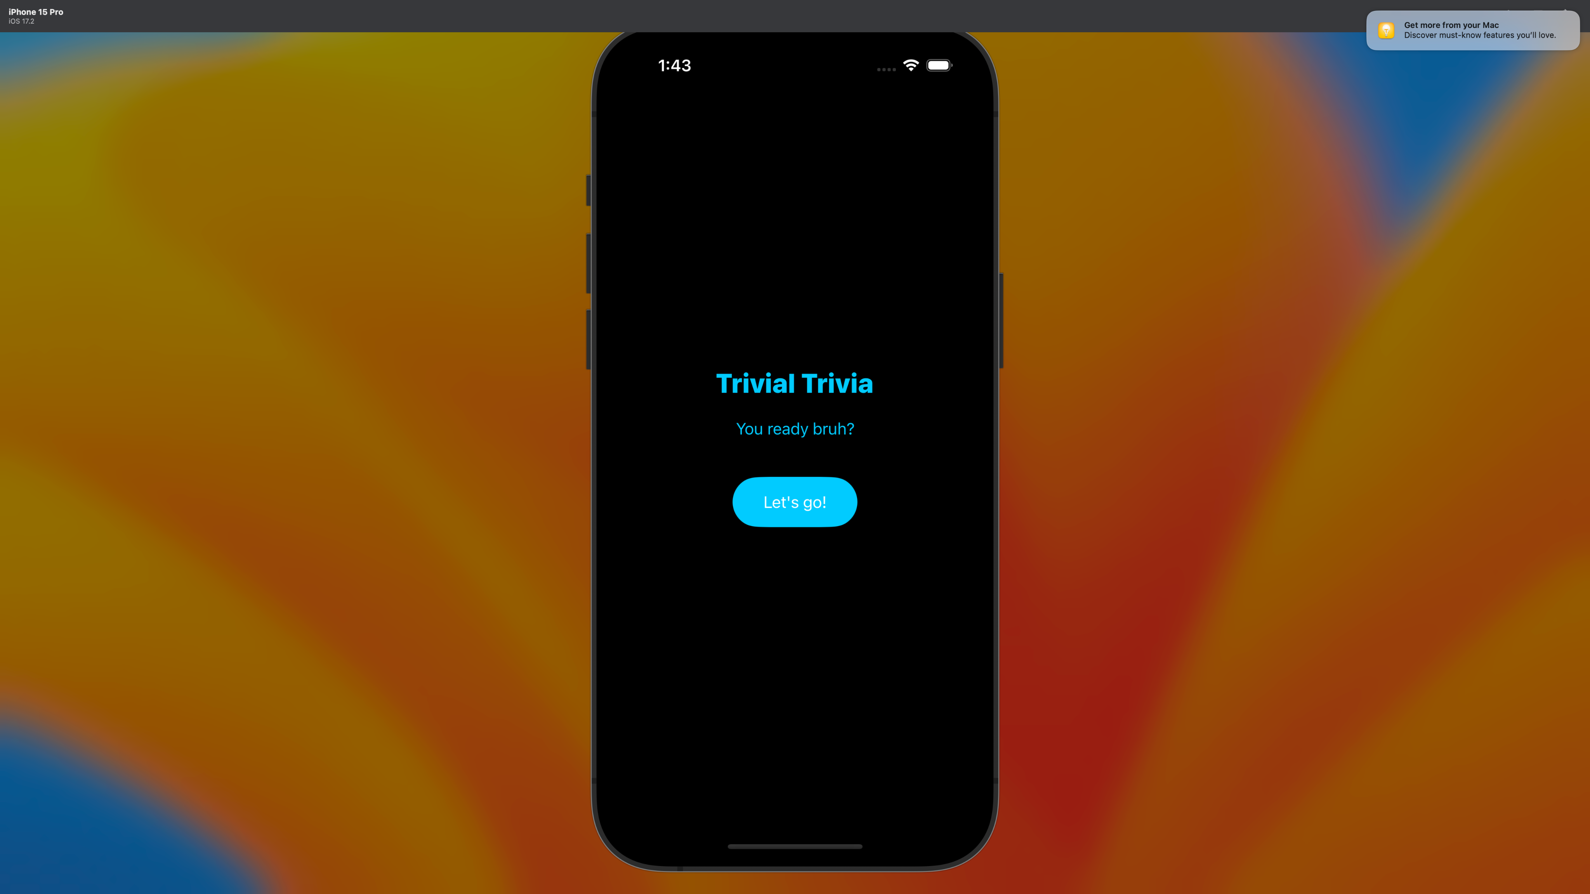

Figure 2: Screenshot from the Trivia Game App

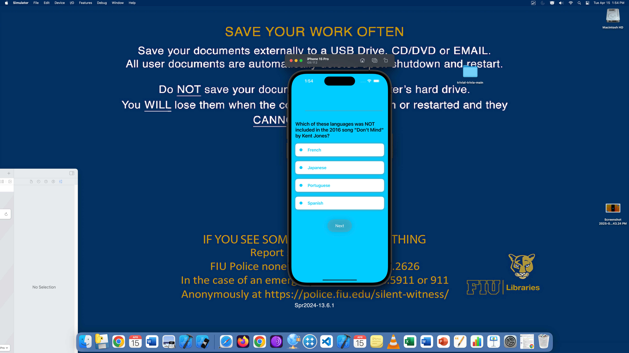

Figure 3: Screenshot from the Trivia Game App

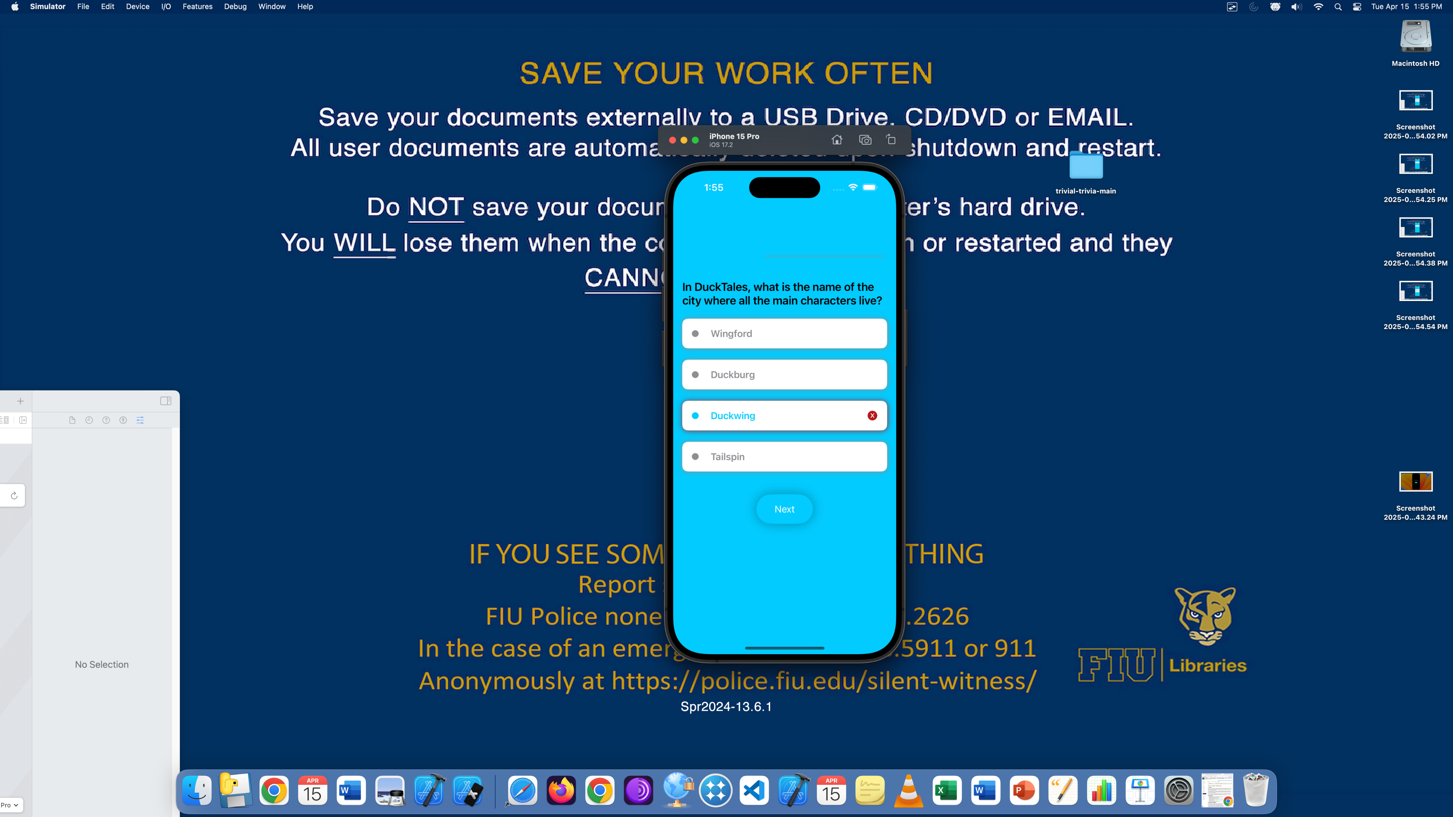

Figure 4: Screenshot from the Trivia Game App

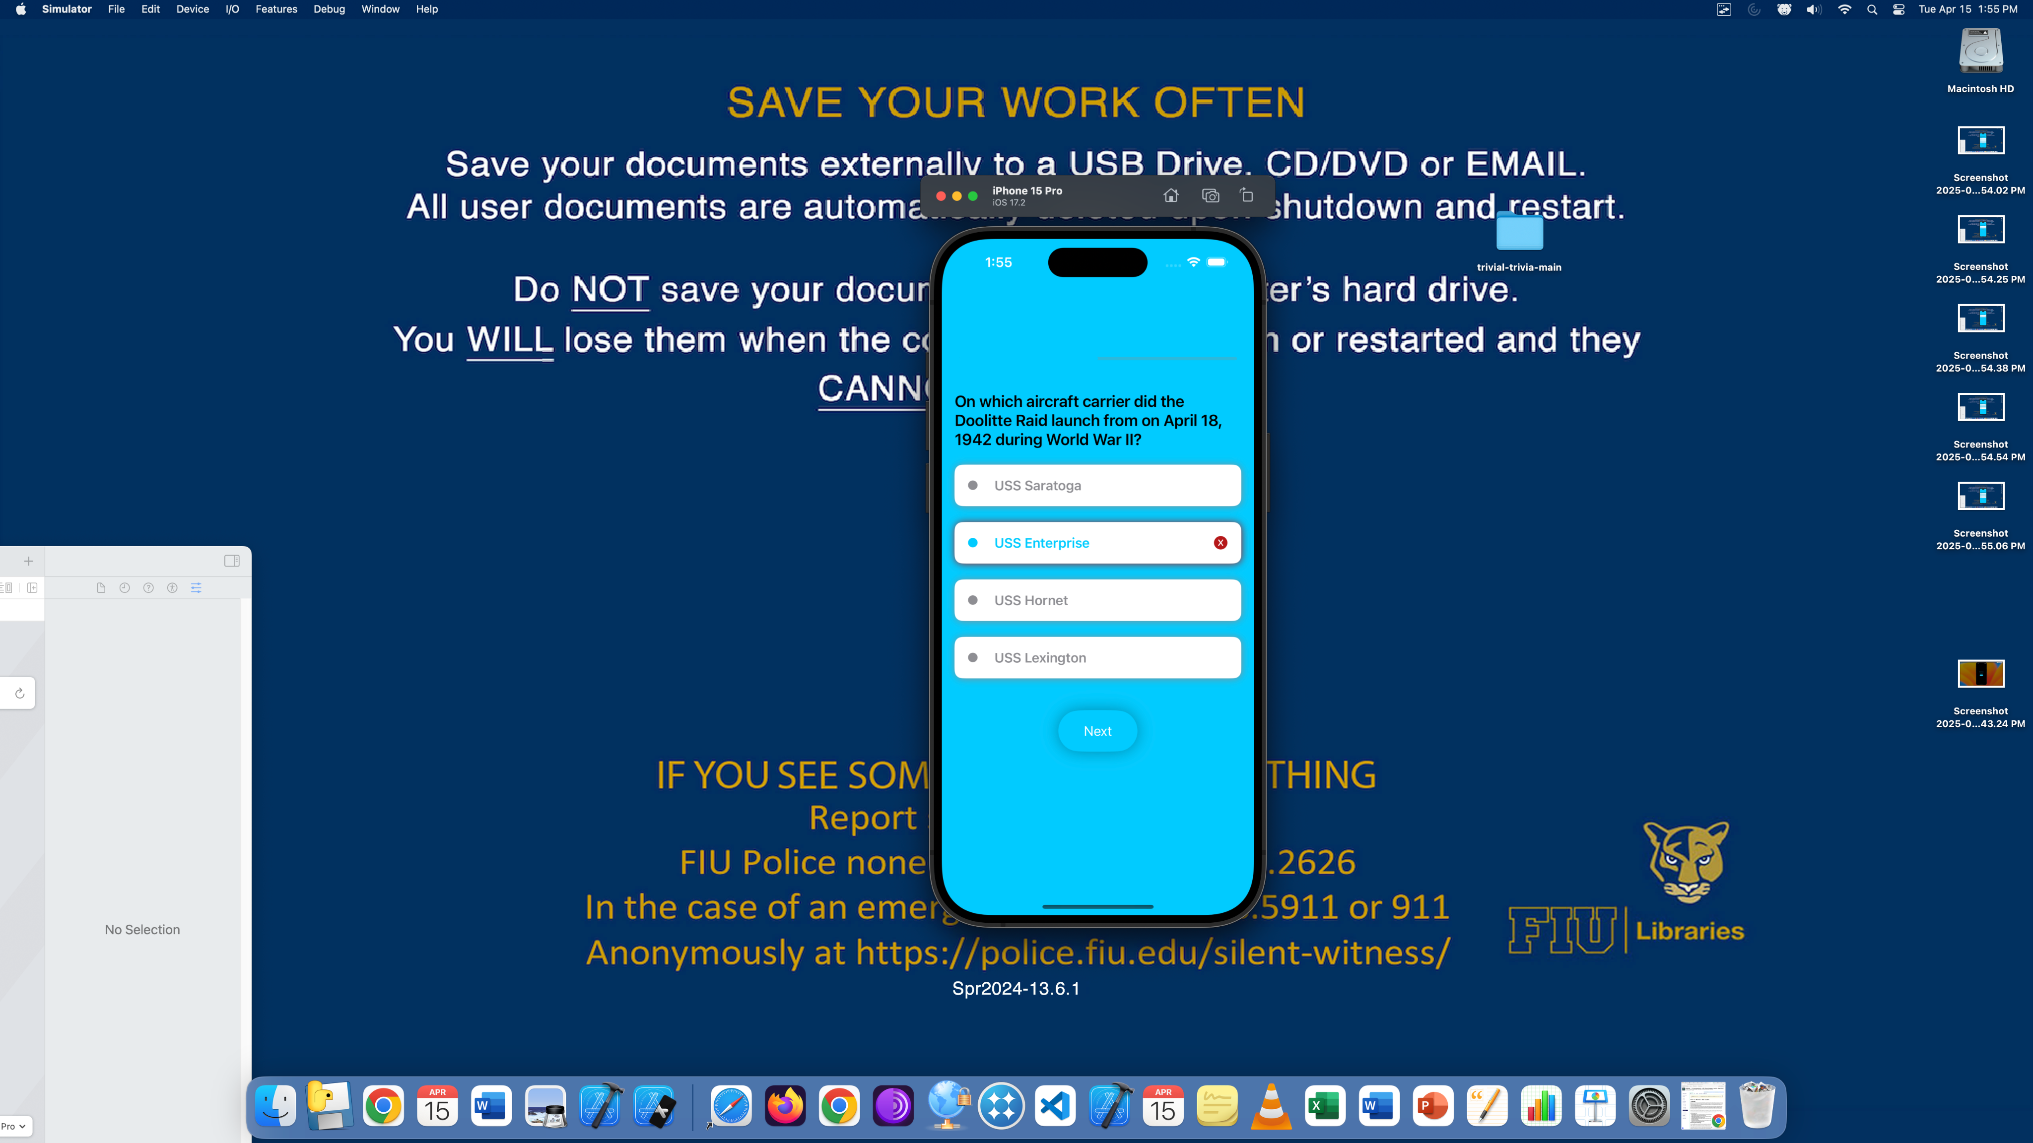

Figure 5: Screenshot from the Trivia Game App

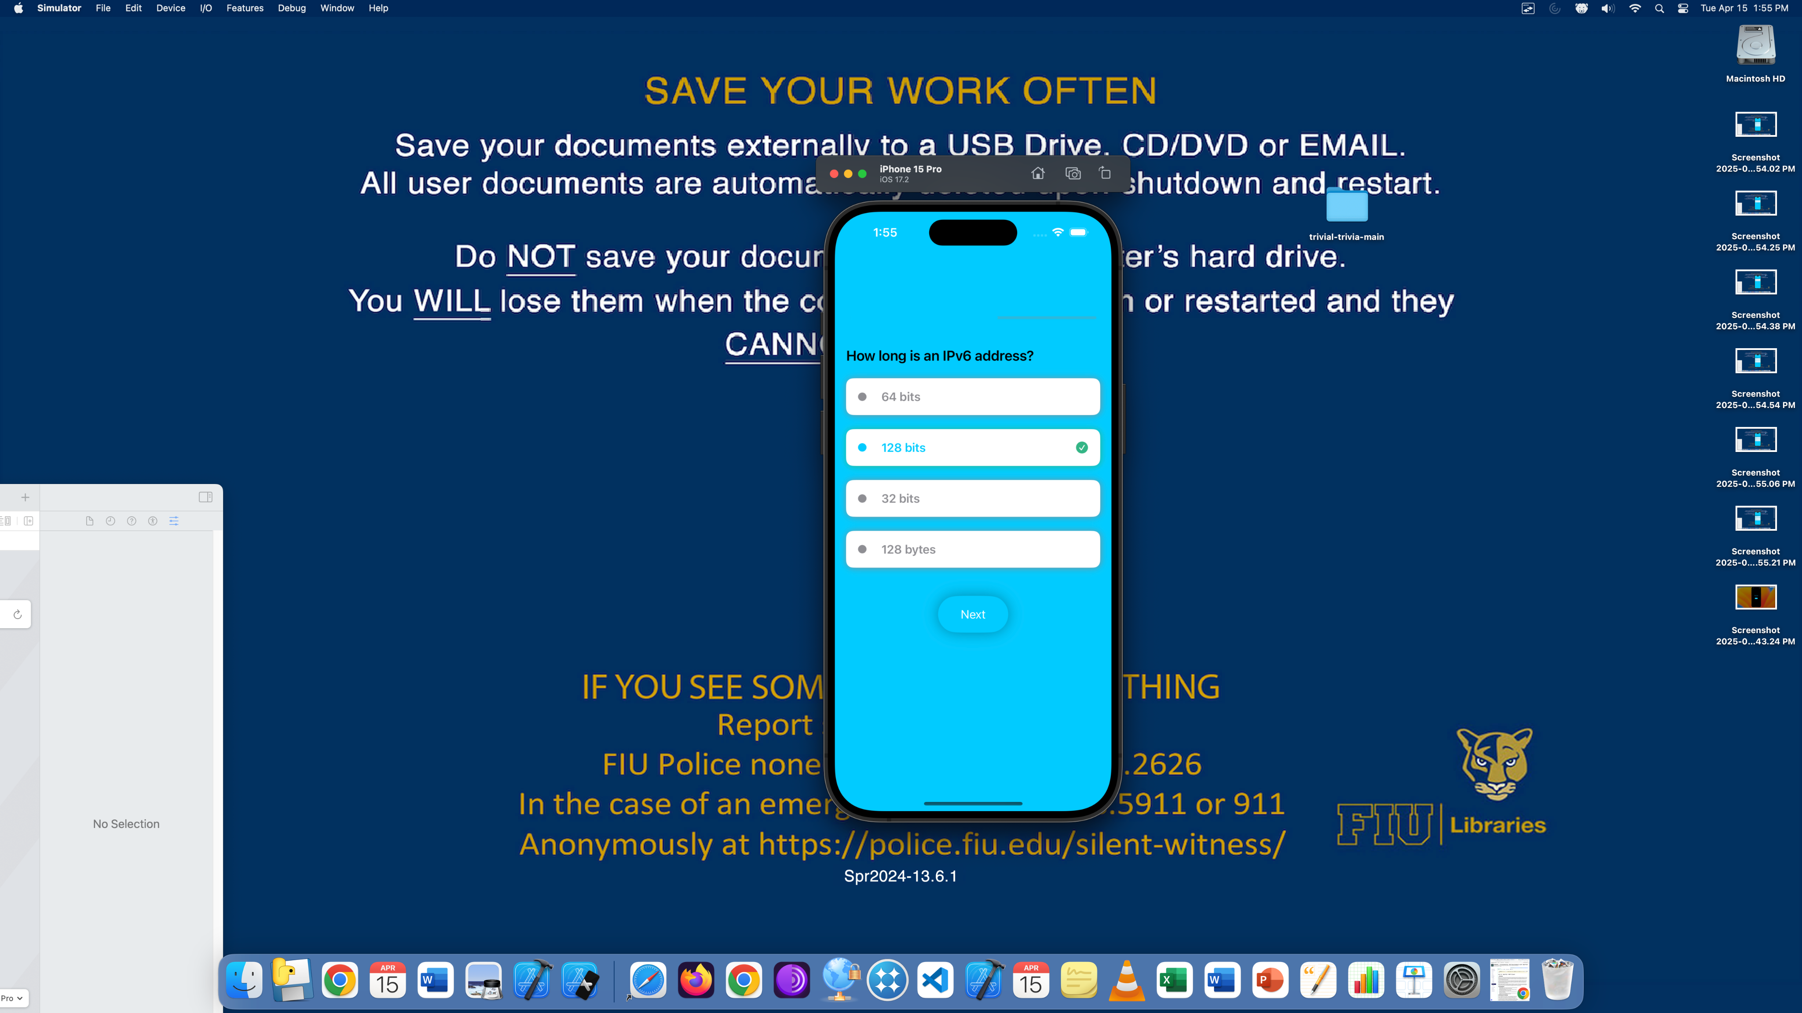

Figure 6: Screenshot from the Trivia Game App

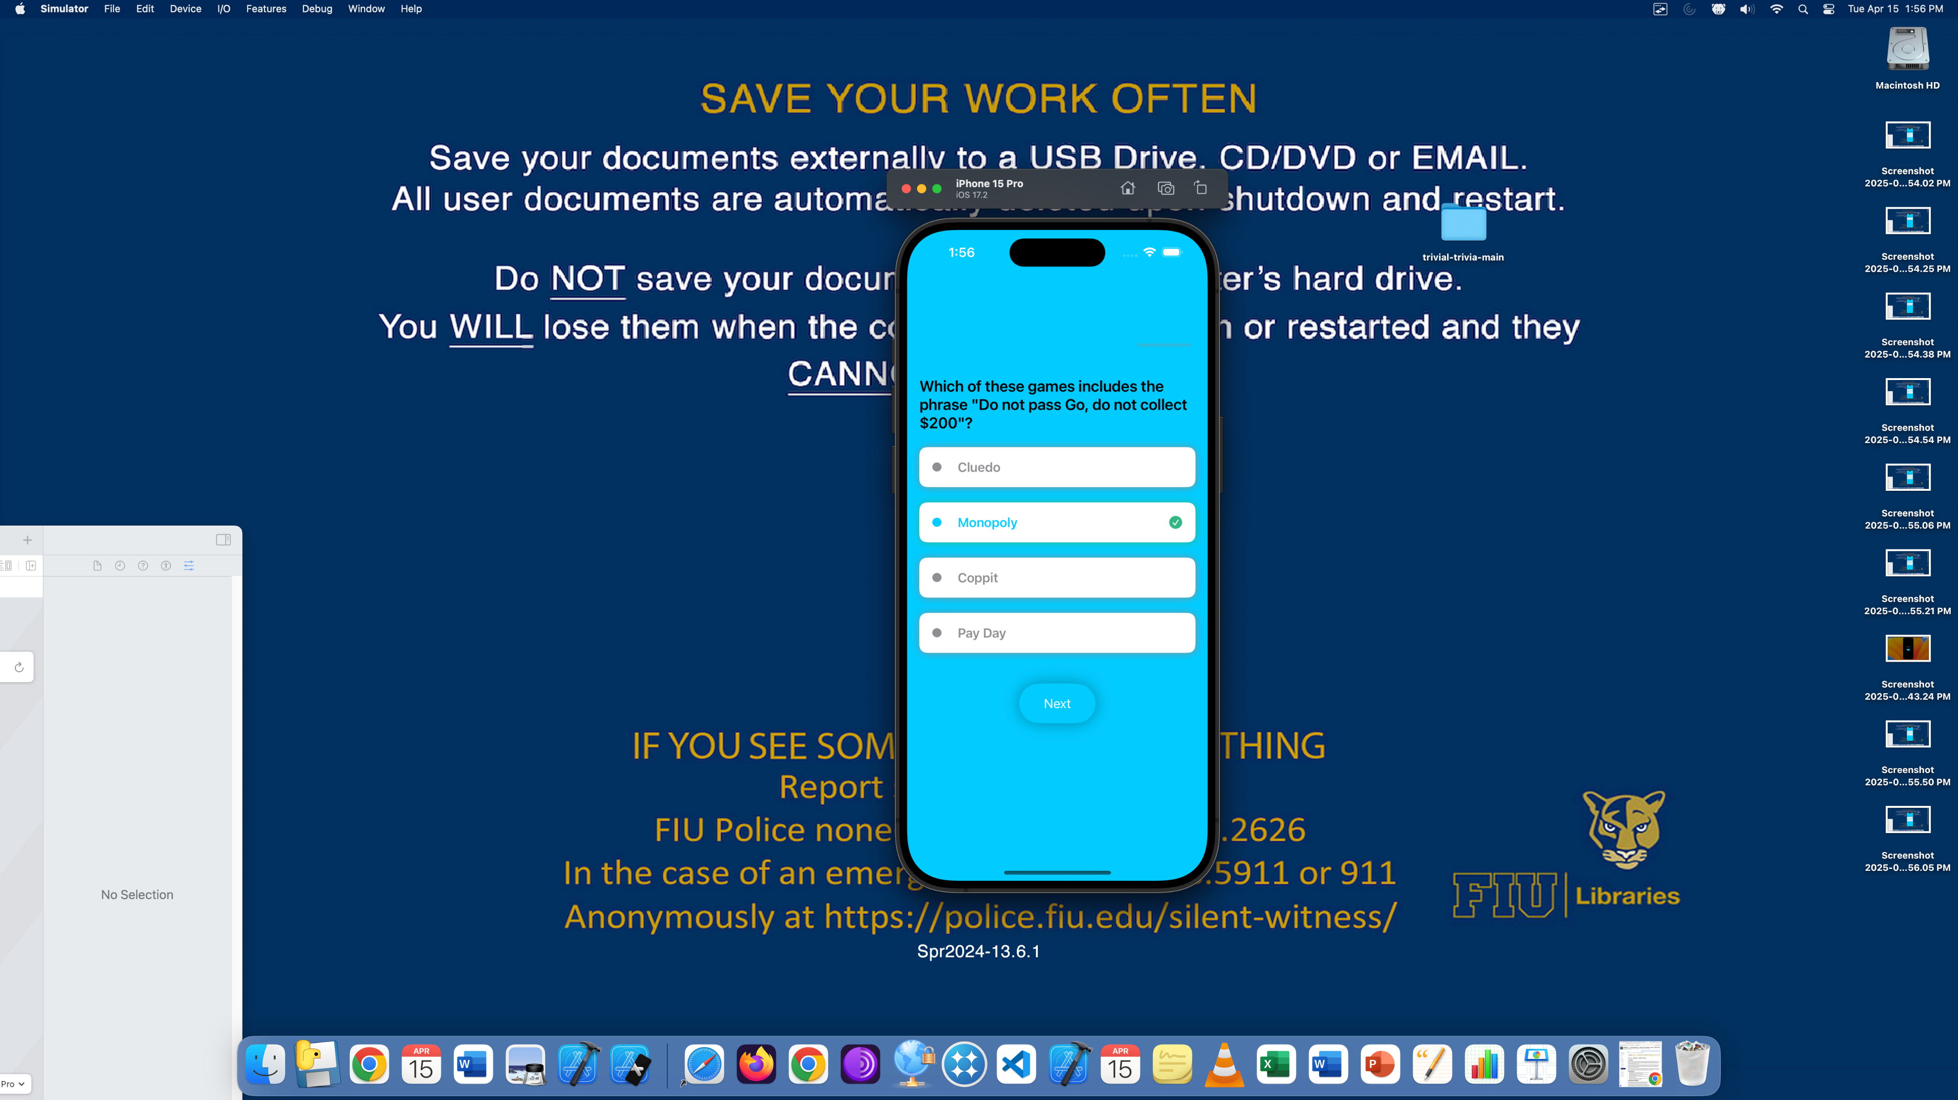

Figure 7: Screenshot from the Trivia Game App

